Scorpio Season 2024

October 22 –November 21

The fixed water sign of Scorpio is the zodiac archetype of Halloween. Still waters run deep, truly, but this is water as steam, like the steaming geysers of Iceland, bursting out from sources deep down in the heart of the hot rock. But what’s the ancient story behind the sign, and what messages does Scorpio bring for us in 2024?

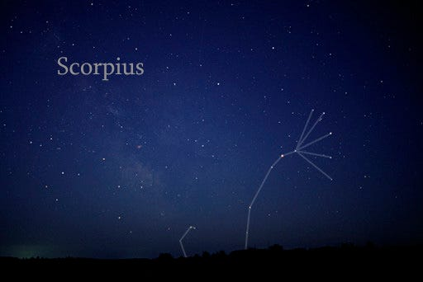

Wiki

Traditional Associations

Zodiac glyph ♏

Scorpio's glyph is symbolic of a serpent representing the life force energy, the flow of that energy and the release of it. Imagine the M as a coil with the energy flow going outward, often with an arrow sign attached. The other "m" glyph in the Zodiac is Virgo is a coiling serpent with its tail folded inward in protective, healing mode.
Ruling planets: Traditional Mars. Modern Pluto following Pluto’s discovery in 1930.
Symbols: Scorpion, Serpent, Eagle/Phoenix (nearby constellation, Aquila, the Eagle.)
Element: Water (but this water STEAMS.)
Quality: Fixed
Keywords: I desire. I transform
Hebrew letter Nun, meaning the snake. Scorpio has three glyphs, the only sign to do so; the snake, scorpion and eagle (or phoenix.) The snake sheds its skin and thus represents transformation, healing and magic.
Colour: Dark red
Birthstone: Yellow Topaz, Opal, Aquamarine, Tourmaline
Body: reproductive/sex organs
Tissue cell salt: calcium sulphate, repair of tissues and resistance to infectious diseases.
Trees: Walnut, hawthorn, blackthorn
Tarot Cards: Death, King of Cups, 5, 6 and 7 of Cups.

The Story in the Stars of Scorpio
Scorpius is a massive, spectacular j- shaped constellation located in the skies over the southern hemisphere near the centre of the Milky Way. In the Northern hemisphere it can be seen in July and August, and in the Southern hemisphere, it’s visible from March to October.

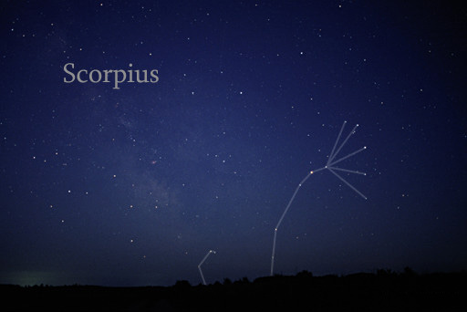

Public Domain. Photo By Till Credner

Nature, science, religion, astronomy and astrology were intertwined in the ancient world. The real life animal scorpion has been here hundreds of millions of years, more than 450 million, compared with our human six million years or so. Sometime around four thousand years ago the Babylonians looked up, discerned the huge and brightly leaning “J”- shape in the summer stars, saw in this the shape of a gigantic scorpion and called this constellation MUL.GIR.TAB – the ‘Scorpion’, literally read as ‘the (creature with) a burning sting.’
The movements and relative positions of Scorpius were mapped by Babylonian magicians and astrologers, who left written records of the omens they observed.
“When a halo surrounds the Moon and Scorpio stands in it, it will cause men to marry princesses, (or) lions will die, and the traffic of the land will be hindered.”
A comet appearing in Scorpius (Scorpio) was read as a dire warning of a coming plague, but when the Sun rose in Scorpius, alchemists saw their chance for the transmutation of lead into gold.

The Scorpio Archetype
Scorpio is The Sorcerer, The Detective, The Hypnotist, The Alchemist and the Necromancer. The zodiac signs represent archetypes, meaning something that is considered to be a perfect or typical example of a particular kind of person or thing. The zodiac signs paint a ‘poetic’ portrait of a person born at a particular time of year. Scorpio is a zodiac season of fast dwindling daylight and with this, a new season of chills and influenza. Its associated tissue cell salt, Calcium Sulphate, performs a cleansing and cooling function in the body. Pus may form a boil, and then the boil bursts, expelling infection and with it, heat of inflammation. This can be viewed as an allegory of world events. What has been festering, must either turn inward, bringing sepsis, rot and death, or must find a way to break out. Scorpio breaks out with heat and violence and/or with stealth, deep state secrecy and intrigue.
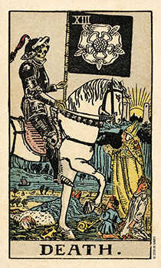
Smith Waite Tarot

The major arcana card in the Tarot representing Scorpio is the Death card, one of the most feared cards in the Tarot deck. Note the Biblical ‘pale horse’ of Death and the white rose. The rose signifies beauty and immortality. All that has ever once been, is recorded somewhere, somehow, forever.
The Death card is not usually about the literal death of any person. It may represent the death of something else, like a project, plan, or relationship. But I have learned in my own experience as a reader, the Death card can mean exactly that, like it or not. The cards can mean exactly what it says on the tin and this has more than once hit hard and very close to home in the literal, physical human sense.
Old age is not our natural birthright. Few animals reach old age living in the wild. It is this sharp focus of such an awareness that gives Scorpio its drive, intensity, its passion, or its preoccupation with the “darker” side of life, and with the occult and the mysterious, but also its power of regeneration, and the drive to procreate new life.
The court card of Scorpio is the King of Cups. We may for reading purposes treat this card as representing a Cancer native or a Pisces native, or as either male or female. Just as we may also read the Queen of Cups for a female Scorpio native, though astrologically, she corresponds with midsummer, the solstice and the cardinal water sign of Cancer.
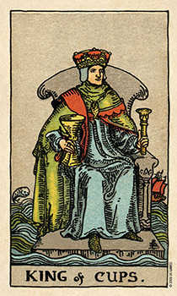
Smith Waite Tarot

Meanings: Water, the sea, a sailor, fisherman, mature male, husband, friend, husband, grandpa, advisor, priest, doctor, counsellor, teacher, academic, artist, poet, musician, deep wisdom, calm, considerate, sensitive, supportive, protective, disciplined, intuitive, psychic, reserved, devoted, aloof, secretive
Scorpio is a magnetic personality, often good in an emergency but in everyday dealings they may be not be straightforward. They can be downright elusive and secretive, and while courteous, generous, sympathetic and loyal, they can have a hot temper, or may exhibit controlling behaviours. Scorpio craves a challenge. They like to unlock puzzles and mysteries and will often be found in high pressure situations, handling serious, intense, traumatic, life or death issues. In the emergency services perhaps, or in the police, detection, crime & prisons, psychotherapy, bereavement counselling or financial management, with an aptitude for research and the power production industries
But you are a unique individual. Your natal sun sign is a major keynote, theme and touchstone in your astrological portrait, but it is nothing like the full picture. Nor are the decans. But if you don’t feel like a ‘typical’ Scorpio, perhaps you are a second or third decan Scorpio, rather than a ‘most typical’ first decan Scorpio.

The Decans of Scorpio

“If you’ve ever wondered why people born in the same sign seem different, the decans can help answer this puzzle,” – astrologer Rachel Lang.

The decans or decanates, known to be in use by astrologers in Egypt 2100 BCE, as evidenced carved on coffin lids, may be far older in astrological usage, and have been described as ‘the thirty-six faces of astrology.’ Each of the 12 signs of the zodiac (Wheel of Life) represents 30 degrees of the 360 degree wheel of the zodiac, tracking the course of the Sun over a year. Each sign is subdivided into three parts of ten degrees each. These are the decan from the Greek word “deka” meaning ten, supplying extra clues and nuance in respect of character and potential destiny.

First Decan Scorpio
Scorpio-Scorpio
Birth Dates: 23 -31 October (0-10 degrees)
Planetary rulers: Traditional Mars Modern Pluto
Tarot card: Five of Cups
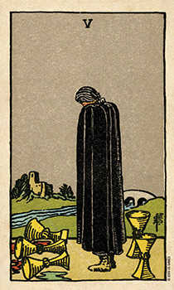
Smith Waite Tarot

Card Meanings: Grief, disappointment and recovery from loss. Taking stock. What is lost? What still remains?
Mars, the original ruling planet of Scorpio (Pluto is the modern ruler) is doubly powerful in this first decan. This is an active, determined, dominant individual, impulsive, high-spirited, and charismatic. They may have intensely deep feelings but keep them well hidden. When the going gets tough, so do they, showing fortitude and a huge amount of willpower- for good or bad. They may exert a creative or destructive influence on their surroundings. Usually, it will be creative. But they need to learn patience, and to exercise self-restraint in order not to self -sabotage their own best chances of success and happiness in their dealings with others.
Scorpio/Scorpio individuals are incredibly driven. They can be more prone than other people to extreme or obsessive behaviours, but show the courage, tenacity, and willpower to overcome odds against them, with the resilience to bounce back after a setback and start afresh.
Famous first decan Scorpio subjects
Hillary Clinton, politician, born 26 Oct 1947, Dylan Thomas, poet, born 27 Oct 1914

Second Decan Scorpio
Scorpio-Pisces
Dates: 1 -11 November (10-20 degrees)
Planetary rulers: Jupiter and Neptune
Tarot card: Six of Cups
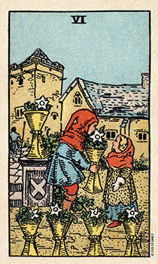
Smith Waite Tarot

Card Meanings: happy memories, nostalgia, home, childhood, children, childhood, old friends, old haunts, reunions
This Scorpio decan, moderated by Pisces and its rulers, Jupiter (traditional) and Neptune (Modern) suggests a less fixed, more changeable and unpredictable nature, sometimes energetic, at other times slow or even sluggish. Here is an innate element of contradiction. Jupiter is the planetary symbol of expansion and changes in fortune, a planetary benefic, but above all, Jupiter is outward facing, while Neptune ‘The Dreamer’ is deeply introverted. This individual’s greatest battles in life may be with themselves, starting at an early age. The influence of Neptune may be an inspiration, or it may become their downfall, if indulging in escapism via any form of addictive behaviours, drugs, alcohol, gambling or other compulsive behaviours. This Scorpio decan often has great natural charisma, with an instinct for medicine and the healing arts. They are happiest with a stable, grounded, loyal, loving home life which will reinforce their self-esteem in healthy ways, and then they can achieve great things.
Famous Second Decan Scorpio subjects:
Billy Graham, evangelist, born 7 Nov 1918, Carl Sagan, astronomer, born 9 Nov 1934

Third Decan Scorpio
Scorpio-Cancer
Dates: 12-21 November
Planetary rulers: Traditional Moon Modern Venus
Tarot card- Seven of Cups

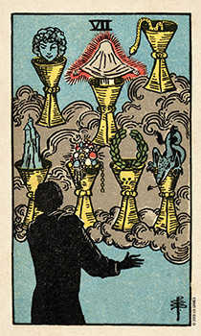
Smith Waite Tarot

Card Meanings: visions, inspiration, possibilities, options, choices, daydreams, escapism, indecision, delusion
This decan is proud, creative and dramatic. The Moon and Venus cool and soften the energy of Mars, indicating a magnetic personality, a natural artist or performer. The influence of the Moon lends these natives the ability to become exceptional nurturers and financial wizards though this Scorpio decan is defensive, and will sting if cornered. They need to get it right, and need to be seen to be right, and they may go to some trouble to make sure of this. Decan 3 Scorpio may have a particularly close relationship with his or her mother, a good thing unless it is allowed to take on too much importance in their relationships with their chosen life partner. These Scorpios are the ones most likely to want to leave a legacy to loved ones and favourite causes. Money, privacy, loyalty and property are of supreme importance. Scorpio/Cancer may be an activist, or a social justice warrior, advocating with force and eloquence, and with a charm that can makes them very effective when they are working with a group for a common cause.

Famous Decan 3 Scorpio subjects
Joe Biden, 20 Nov 1942, Robert Kennedy, born 20 Nov 1925, King Charles 111, born 14 Nov 1948

The Cusps of Scorpio
Oct 23-Oct 25: This is Scorpio with Libra tendencies ruled by Mars and Venus
Nov 19-Nov 21: This is Scorpio with Sagittarius tendencies ruled by Mars and Jupiter

Astrology of Scorpio Season 2024

This is yet another intense month of powerful on-going retrogrades and challenging squares and oppositions. But we also have a scattering of encouraging and constructive trines and sextiles.

A few key dates to watch:

October 22: Sun Enters Scorpio. We enter a period of transformation, intensity, and introspection.
October 21-22: Sun sextile Pluto is a great time to learn something new or make new contacts, meeting someone with a view to investing in a project or taking your work to a new and higher level.
October 22-23: Sun square Pluto, intense energy for good or ill. Beware untruths and people engaging in dodgy dealings
October 24: Mars in Cancer sextile Uranus in Taurus. A window for breakthroughs in areas where we've felt stuck, likely to be focussed on domestic matters or in political terms, homeland security.
October 28: Mars in Cancer trine Neptune in Pisces. A gentle aspect softening the energy of Mars. A day for inspired action, where dreams take form. Try out a new strategy.
‍
October 28: Venus in Sagittarius square Saturn in Pisces. This challenging aspect may bring feelings of isolation or restriction in love and finances. Venus square Saturn can make it difficult to connect with others, leading to misunderstandings or a sense of distance. Use this time to reflect on your values and ensure relationships and commitments are built on a solid foundation.
‍
October 30: Mercury in Scorpio opposition Uranus in Taurus. Expect disruptions in communication as Mercury opposes Uranus, creating a clash between traditional thinking and innovative ideas. This can bring sudden revelations or unexpected news, so be prepared for surprises. You will need to stay flexible and open-minded.‍
October 31: Mercury in Scorpio trine Neptune in Pisces. It is Halloween. This powerfully psychic aspect heightens intuition, an excellent day for divination, meditation, experiencing, exploring or solving mysteries, unlocking secrets and witnessing the unseen side of life.
November 1: New Moon in Scorpio. 09°34.’ Tarot card 5 Cups. Loss, disappointment and recovery. Powerful lunar event, deep introspection and the initiation of profound changes to do with new information, finances, relationships and family matters, legacies or legalities.
November 1-6: Mars opposite Pluto. The two planetary rulers of Scorpio, sign of Death and Transformation are pitted against one another. Not easy. Arguments could spark like wildfire. Confrontations, powerful adversaries, personal or circumstantial, and this is happening right at the time of the US Election November 5. We already know this will most likely be a combative or even combustible event. Tensions are super high.
2: Mercury in Scorpio trine Mars in Cancer is about mental focus and drive. An excellent window for strategic planning and assertive communication. It’s a good day to take decisive action on an important matter to do with finances and home matters.
November 2: Mercury in Scorpio sextile Pluto in Capricorn insights into hidden aspects of our lives. It's a powerful transit for uncovering new information and making transformative decisions.
November 2: Mercury enters Sagittarius This ninth house transit of education, publishing, far travel and visionary experience encourages us to study, explore new ideas and broaden our horizons.
November 3: Mars in Cancer opposition Pluto in Capricorn intense and potentially challenging energies or power struggles, requiring caution and integrity.
November 3: Venus in Sagittarius opposition Jupiter in Gemini excess and overindulgence in relationships and finances. It’s important to avoid overextending ourselves during this transit.
November 3: Mars enters Leo a surge of confidence and creativity.
November 4: Sun in Scorpio trine Saturn in Pisces This trine stabilizes our efforts and brings a sense of responsibility and discipline. It’s an excellent time for making long-term plans and committing to our goals.
November 11: Venus Enters Capricorn A time for practical and serious approaches to love and finances.
November 12: Mercury in Sagittarius Square Saturn in Pisces Communication challenges, misunderstandings. Restraint, patience and persistence required.
November 15: Full Moon in Taurus 24°00.’ Tarot card 7 Pentacles. Investing for the long haul. A great time to complete on something to do with money or property or a beloved project, while this powerful lunation in Scorpio season talks about eighth house legacies, wills and inheritance of all kinds. But discussions with a partner could be fraught. Proceed with care.
November 15: Saturn Goes Direct in Pisces at 12° Pisces 42′. Tarot card 9 Cups. All manner of pleasant things attach to this card, however, we need to safeguard personal and professional boundaries. Duty calls but things are muddled.
November 16: Sun in Scorpio opposition Uranus in Taurus unexpected changes and disruptions. It’s a time to be flexible and open to new possibilities, even if they come suddenly.
November 18: Mercury in Sagittarius opposition Jupiter in Gemini - This opposition can amplify our thoughts and communications, sometimes to the point of exaggeration. It’s important to stay grounded and avoid making promises we can’t keep.
November 18-10: Sun in Scorpio trine Neptune in Pisces
A potentially magical time for intuition and creativity. It’s a great time for lucid dreams, psychic hits and artistic pursuits and spiritual practices.
November 19: Pluto enters Aquarius until 2043. This is THE transit of Scorpio season 2024, announcing revolutionary changes in the eleventh house territory of technology, ideas, society, and collective governance versus personal freedom. Changes may be immediate, sudden and abrupt.
November 21: Sun enters Sagittarius. This transit of the sun into the Ninth House of study, far travel and philosophy encourages us to learn, to teach, to seek new experiences and expand our horizons.

Wishing a very Happy Birthday season to our savvy, deep and subtle Scorpio friends in 2024.

Katie-Ellen Hazeldine, BA Hons, Cert Ed, is a psychic Tarot reader and writer in the UK, and was once put to the test in “Fate and Fortune” magazine, reading live in a feature called “How Did They Know That?”

Twitter/X: https://twitter.com/truetarottales
Substack: https://katieellenhazeldine.substack.com/

